PDF Merge Library
Document number | DOC067265
Document revision | 1.0
Document status | Standard
Issue date | 2009-09-25
Security status | Mnemis & Mera NN confidential
Master document location | http://customers.mera.ru/?ref=DOC067265
Contents
© 2009 Mera NN
All rights reserved.
Uncontrolled copy: The master of this document is stored in an electronic database and may be altered only by authorized persons. While copies may be printed, it is not recommended. Viewing of the master electronically ensures access to the current issue. Any hardcopies taken must be regarded as uncontrolled copies.
1. Version history 3
2. General 4
2.1. Purpose 4
2.2. Scope 4
3. Reference documents 5
4. Abbreviations and definitions 6
5. Overview 7
6. Assumptions and LIMITATIONS 8
7. Merge oveview 9
8. Interfaces 10
8.1. Overview 10
8.2. API using 11
9. lIBRARY design 15
10. Test environment 20
10.1. Test tool description 20
10.1.1. Building of test tool 20
10.1.2. Tool interface 20
10.2. Configuration file of test tool 20
10.3. Test cases 21
11. Appendixes 22
11.1. Appendix A. Test tool configuration file example 22

Version history
Revision | Date | Status | Comments
1.0 | 2009-09-25 | Standard | Creation

General

Purpose
The purpose of this document is to describe PDF merge library.
This document contains description of API, main entities, class and sequence diagrams in order to show how these entities interact with each other.
Also document contains description of test environment used to check PDF merge library functionality.

Scope
Document is intended for those who are going to use PDF merge library.

Reference documents
1 | DOC064752 "Uniboard library requirements"

Abbreviations and definitions
Uniboard – software which allows to make and save various annotations in existing PDF files
Base document — input original document for PDF merge library
Overlay document – document generated by Uniboard
Output document – document produced by PDF merge library
PDF merge library – software library which allows to merge base and overlay documents

Overview
PDF merge library is a module that merges PDF files ("base" and "overlay" documents) within Uniboard.
The "base" document is a file which user imports to Uniboard. Uniboard renders the PDF and displays it. User may annotate the content of this document and then save resulting document. Such resulting document is called “overlay” document.

Each page of overlay document consists of the base page as heavy JPEG-image and image of user’s annotation if any. This makes the overlay document much bigger then initial base document in most cases.

PDF merge library allows to merge the “base” and “overlay” documents by removing of heavy images with content of base pages and substituting them by original content from base document.
It means that after merge the resulting document will contain the original content of base document and user annotations from overlay document.
In most cases output document will have significantly less size than overlay document without page content loosing.
The compression ratio highly depends on the content of base document. The best compression will be achieved for base documents with text only.

Assumptions and LIMITATIONS
Number | Comments
1 | PDF merge library can be compiled on different platforms - Windows XP/Linux (Fedora, Debian)/Mac OS X (10.x)
2 | Library does not have any GPL dependant source code
3 | Compatible with Visual Studio C++ 2005 and GCC 4.2+
4 | Uses free open-source zlib library V1.2.3
5 | Library uses Standard C++ Template Library (STL)
6 | Output document formatting during printing is out of scope of library
7 | Total size of currently processed input documents are limited by available memory and underlying operating system limitations
8 | Library supports PDF files with versions 1.0 – 1.4
9 | Encrypted PDF files are not supported

Merge oveview
PDF merge library is intended to merge of several base documents and corresponding single overlay document into output document.

Merge processing and generation of one output document can be described by the following steps:
- User provides all needed base documents to the library
- User provides single overlay document with or without user annotations
- User defines merge parameters for each page of output document.
- User initiate merge of the document. PDF merge library performs needed merge depending on specified merge parameters. After merge is complete the resulting document is stored in memory.
- User initiate saving of generated output document into specified file.

Output document is generated basing on overlay document. It means that number of pages in output document always equal to number of pages of overlay document.

Library allows to define some simple transformations of base and overlay page content before putting it to output page like:
1. Anchoring of source page (base or overlay) at the defined coordinates
2. Scaling of source page (base or overlay) comparing to their original size
3. Rotation of source page (base and overlay) comparing to its original orientation by angles of multiple 90 degrees

Interfaces

Overview
PDF merge library API allows to define separate parameters of merging for each page of base and overlay documents in output file.
The full list of the parameters passed to the module is:
- name(-s) of base document(-s)
- name of overlay document
- name of output document
- parameters of merge for each page of output document.

The following parameters can be specified by user for each page of output document:
Name | Meaning | Units | Comments
W | Width of output page | Default PDF units
H | Height of output page | Default PDF units
X1,Y1 | Coordinates in output page where to put content of base page during merge | Default PDF units | 0,0 is located at left-bottom point of page. X-axis goes to right, Y-axis goes to up
X2,Y2 | Coordinates in output page where to put content of overlay page during merge | Default PDF units | 0,0 is located at left-bottom point of page. X-axis goes to right, Y-axis goes to up
Z1 | Scaling of base page comparing to its original size |  | >1 – increasing  <1 – decreasing
Z2 | Scaling of overlay page comparing to its original size |  | >1 – increasing  <1 – decreasing
A1 | Angle to rotate content of base page comparing to its original orientation before putting to output page | Degrees  [-270,  -180,  -90  0  90  180  270] | Rotation is performed in counterclockwise direction
A2 | Angle to rotate content of overlay page comparing to its original orientation before putting to output page | Degrees  [-270,  -180,  -90,  0,  90,  180,  270] | Rotation is performed in counterclockwise direction
B1 | Omit content of base page into output | true/false
B2 | Omit content of overlay page into output | true/false

API using
The library provides C++ interface.
Dedicated namespace merge_lib is used for all source files of PDF merge library.
There is the main class Merger that performs actual merge of pages into destination.
The usage of this class is following:
- Include the following header files where interface definitions are located
#include "Merger.h"
#include "Transformation.h"

- Create instance of this class
Merger merge;

- Then it is needed to provide base documents for parsing. For example:
merge.addBaseDocument(“doc1.pdf”);
merge.addBaseDocument(“doc2.pdf”);

During this step library will parse the content of these documents. In case of error exception with some text description will be thrown.

- Then user must specify the whole merge parameters for base documents and overlay document.
Merge parameters defined by a vector MergeDescription, which contains instances of MergePageDescription class;
typedef std::vector<MergePageDescription> MergeDescription;

User must provide description of merge for each page it wants to process and put it into the MergeDescription vector.
Each MergePageDescription class defines all parameters for merge of one page of base document and one page of overlay document.

Class MergePageDescription defines the following parameters (provided by constructor):
- Width of output page - W
- Height of output page - H
- Page number in base document
- Name of base document from which we take this page
- Base page transformation relative to output page – instance of class TransformationDescription
- Overlay page number - int
- Overlay page transformation description relative to output page – instance of class TransformationDescription
- B2 flag to omit overlay page in output document (true – omit overlay page content). If true, then content of overlay page will not be put into output document at all.
- B1 flag to omit base page in output document (true – omit base page content). If true, then content of base page will not be put into output document at all.

See below the constructor definition of class MergePageDescription:
MergePageDescription::MergePageDescription(
double outputPageWidth,
double outputPageHeight,
unsigned int basePageNum,
const char * baseDocName,
const TransformationDescription & baseTrans,
unsigned int overlayPageNum,
const TransformationDescription & overlayTrans,
bool omitOverlayPage = false,
bool omitBasePage = false )

Class PageTransformation allows to define the following parameters of transformation:
- X,Y – position of left-bottom coordinate of content page in output page, in PDF units. It defines how to shift left-bottom point of transformed original page in output page coordinate system. It must be noted, that library always takes left-bottom point of transformed content page in output page coordinate system despite of rotation or scaling of content page.

- Z - Scale (double) , this defines whether size of content page should be increased (>1) or shrinked (<1).

- A - Rotation(int) – in degrees. Allowed values are 0,90,180,270,-90,-270,-180. The content of page will be rotated according to it in counterclockwise direction.

See below PageTranformation constructor definition
TransformationDescription::TransformationDescription(
double x = 0, // leftBottomX coordinate
double y = 0, // leftBottomY coordinate
double scale = 1, // scale (by default = 1 = NONE
int angel = 0): // rotation (0,90,180,270,-90,-180,-270)

Examples of transformation definition:
TransformationDescription pageTransformations(0,0,0.5,-90);
The page will be reduced by 2 and rotated -90 degrees. Left-bottom point of transformed page will located in 0,0 coordinate of output page.

TransformationDescription overlayTrans(100,20,0.5,-90);
In this example page will be shrinked by 2 and rotated -90 degrees. Then the lef –bottom point of transformed page will be shifted by 100 units on X-axis and 20 units on Y-axis. Note, that this translation will be done in output page coordinate system.

The examples of one MergePageDescription are the following:
MergeDescription mergeInfo; // is a vector of MergePageDescription instances

MergePageDescription doc1Page1(842,595, 1, "in.pdf", pageTransformations, 2,overlayTrans,false,false);
// defines merge of first page of in.pdf base file and 2 page of overlay document.

mergeInfo.push_back(doc1Page1); // put into vector

MergePageDescription doc3Page5(842,595, 3, "in33.pdf", pageTransformations, 5,overlayTrans,false,true);
// Defines merge of 3-d page of in33.pdf and 5 page of overlay document, content of 5 page will be skipped in output page
// thus output will contain only overlay page

mergeInfo.push_back(doc3Page5); // put into vector

- After all merge description is defined, the user may call the method merge.

merger.merge("overlay.pdf", mergeInfo); // perform merge processing

During this step PDF merge library loads overlay document and performs merge according to mergeInfo.

In case of error the library throws exception with string definition of problem.
So recommended way of calling merge is something like
try
{
merger.merge(param->overlayName.data(),mergeInfo);
}
catch( exception &ex )
{
cerr<<"Cannot merge the file, error:"<<ex.what()<<endl;
// user error processing
}

- After merge is complete, the result file can be saved like:
merger.saveMergedDocumentsAs(“output.pdf”);

Complete example of the PDF merge library interface using can be found in main.cpp file, included into delivery of PDF merge library source code.

lIBRARY design
This chapter contains library’s description of classes and main algorithms.
Picture 1 shows the relationship between main entities of PDF merge library. The Merger uses the Parser in order to create instance of Document. Document class contains all PDF file objects (which are represented by Object class). Also Document keeps map of all Pages (which represents the /Page object of PDF document).
Picture 1 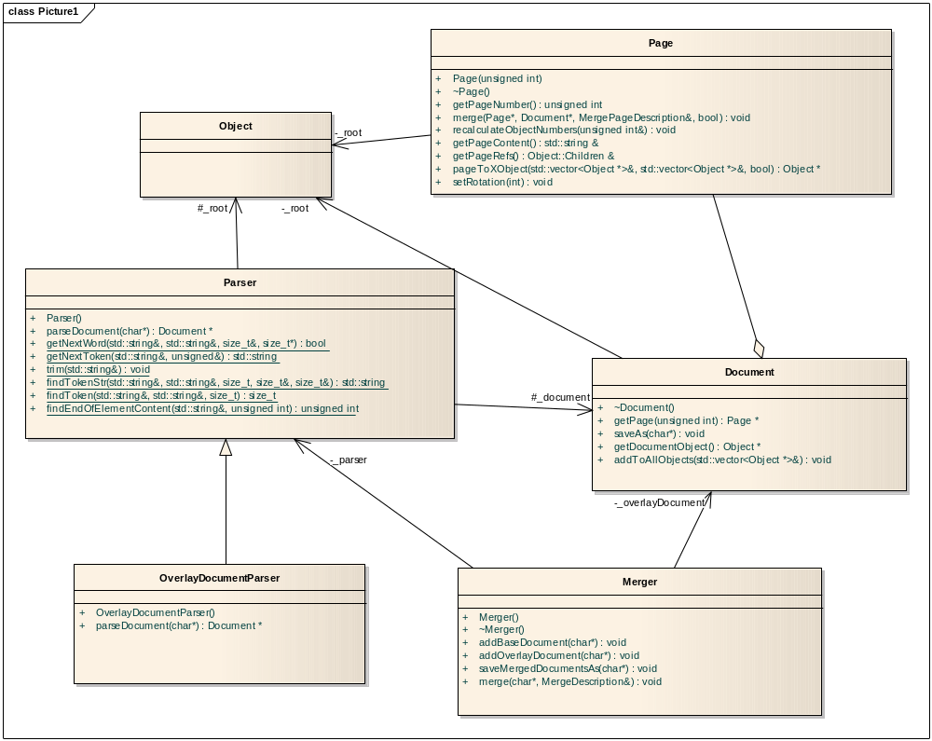

Document creation process is shown on the following sequence diagram the:
Picture 2 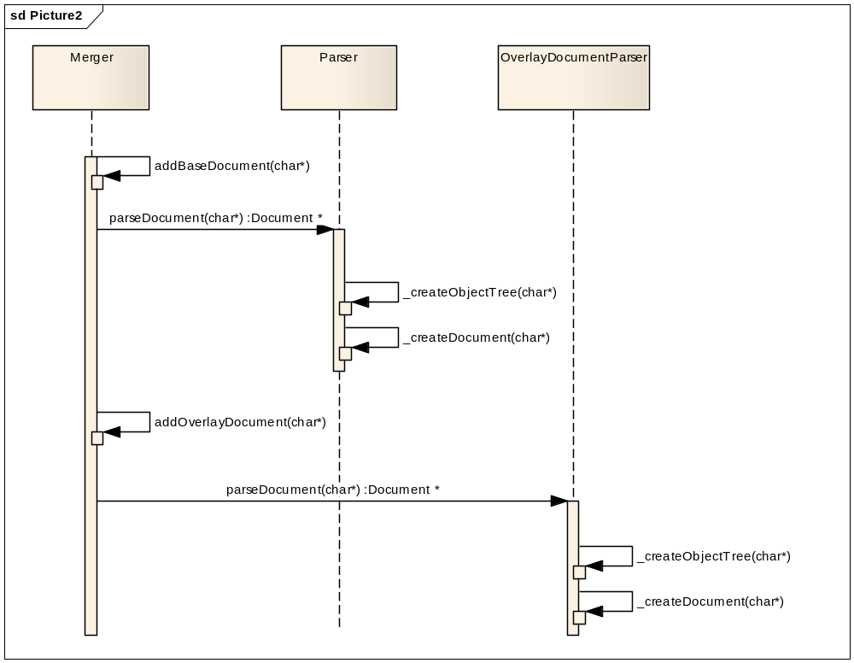
To add new Document instance to Merger, the PDF file must be read, for each object of this file Object instance must be created, and for each page in document the Page must be created too. As you can see there are two parsers. The main difference between them is memory usage way during the parsing process. The Parser allocates memory for whole of file at parsing start-up and never reads from hard disc during the parsing. This is the fast way, but a lot of memory is required. By-turn the OverlayDocumentParser reads the file parcel wise during the parsing and so few memory is needed but it is a bit slower way.

Please see the merge procedure on the following diagram
Picture 3 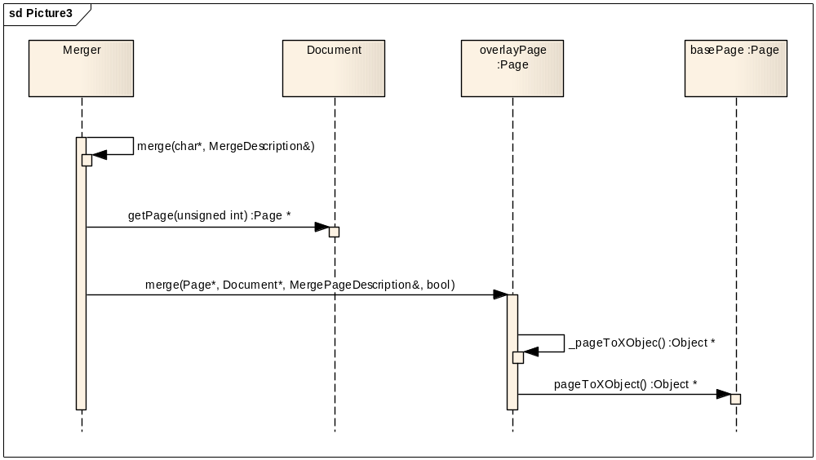

This procedure is repeated for each Page of overlay document. Base page number, base document name and other parameters are retrieved from MergePageDescription. In the following class diagram the relationship between all classes which keeps the library’s input parameters are shown.
Picture 4 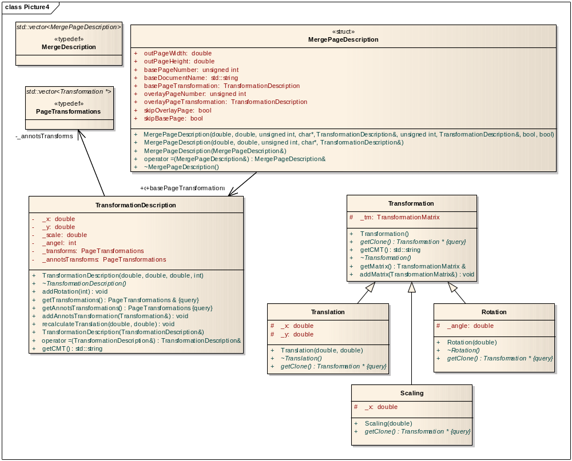

In order to code and decode object’s stream Decoder and it’s sub-classes have been implemented. A lot of streams are huge that’s why all streams load to the memory only when it is needed. Filter class is an proxy class which encapsulate coding and decoding any stream. This class contains all decoders and delegates stream processing to corresponding decoder. FlateDecoder and LZWDecoder provides methods for encoding and decoding streams which has been coded by Flate and LZW filters. Class FilterPredictor implements PDF predictor algorithms which are used sometimes in PDF files as optional transformation of content streams.
Please see 8.2 for additional information about usage of these classes.
Picture 5 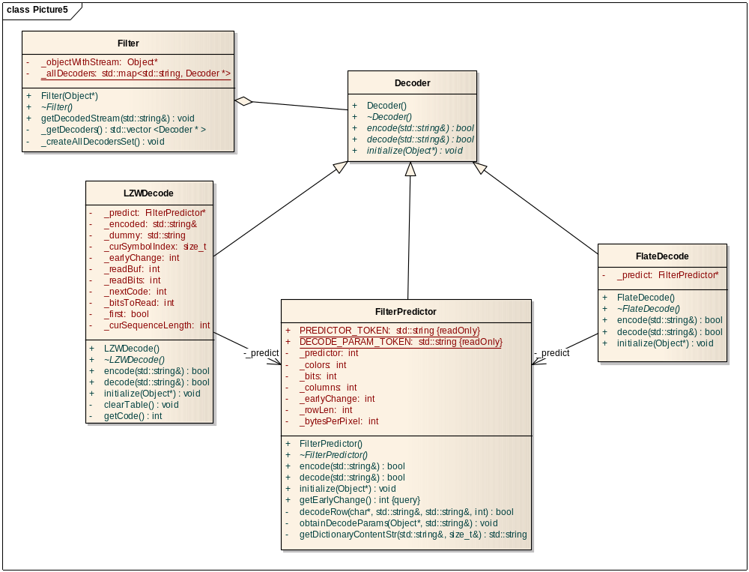

Test environment
This section describes test environment used to check and validate functionality of PDF merge library.
Test environment contains the following parts:
- Test tool pdfmerge.x which encapsulates PDF merge library
- Configuration file for tool
- Various input PDF files to check different cases of merging process.
Test environment can be run on all platforms supported by PDF merge library.

Test tool description
The tool pdfmerge.x is intended to execute merging of PDF files using PDF merge library.

Building of test tool
On Linux/MacOS-X platform the tool can be compiled by running make command in the directory of PDF merge library.
On Windows platform the tool can be compiled by Visual Studio by creating C++ Console Application project.

Tool interface
The tool is a console application.
It accepts as input the one or list of configuration files where merge process is described.
The tool reads the configuration file and processes it executing merge according to defined parameters.
Example of running of test tool:

pdfmerge.x pdf.cfg
Loading configuration file pdf.cfg
Trying to merge overlay file:examples/overlay.pdf and output:examples/pdf1_out.pdf
Cannot parse base document examples/pdf1.pdf File with verion 1.6 is not currently supported by merge library

Trying to merge overlay file:examples/overlay.pdf and output:examples/pdf2_out.pdf
OK, file examples/pdf2_out.pdf is ready

Configuration file of test tool
Test tool configuration file is simple text file which contains sections.
Each section defines the merging for one output document.
Section is started by string with [] symbols. Inside these delimeters the file of overlay and output documents must be specified. Then section may contains various number of lines, each line specifies merge parameters for one page of output document.
Symbol # can be used for line commenting.
See in 11.1 example of the test tool configuration file.

Test cases
Test environment contains several prepared files to test main functionality of PDF merge library.
The number of test cases can be easily increased by creating appropriate configuration file or extending existing ones.

Appendixes

Appendix A. Test tool configuration file example
# overlay name - output name
#
[ overlay.pdf out.pdf ]

# merge description
#Width
# | Height
# | | Number of Base Page
# | | | Name of base document
# | | | | X coordinate of base in output
# | | | | | Y coordinate of base in output
# | | | | | | scale of base page
# | | | | | | | rotation of base page in output
# | | | | | | | | overlay page number
# | | | | | | | | | X of overlay document
# | | | | | | | | | | Y of overlay document
# | | | | | | | | | | | scale of overlay
# | | | | | | | | | | | | rotation of overlay
# | | | | | | | | | | | | | skip overlay in output
# | | | | | | | | | | | | | | skip base in output
# | | | | | | | | | | | | | | |
842 595 1 in.pdf 0 0 0.5 270 1 6 -125 0.685 270 0 0
842 595 2 in.pdf 214 -15 0.740 0 2 0 0 1 0 1 0
842 595 3 in.pdf 214 -15 0.740 0 3 0 0 1 0 1 0
842 595 4 in.pdf 214 -15 0.740 0 4 0 0 1 0 1 0
842 595 5 in.pdf 214 -15 0.740 0 5 0 0 1 0 1 0

[ tests/anots/overlay.pdf tests/anots/out.pdf ]
# merge description
#Width
# | Height
# | | Number of Base Page
# | | | Name of base document
# | | | | X coordinate of base in output
# | | | | | Y coordinate of base in output
# | | | | | | scale of base page
# | | | | | | | rotation of base page in output
# | | | | | | | | overlay page number
# | | | | | | | | | X of overlay document
# | | | | | | | | | | Y of overlay document
# | | | | | | | | | | | scale of overlay
# | | | | | | | | | | | | rotation of overlay
# | | | | | | | | | | | | | skip overlay in output
# | | | | | | | | | | | | | | skip base in output
# | | | | | | | | | | | | | | |
842 595 1 tests/anots/in.pdf 233.4 -14.5 0.6955 0 1 0 0 1 0 0 0

